Tyler Hollingsworth

CS-340

10-23-2022

**Data Aggregation Pipeline**

1)

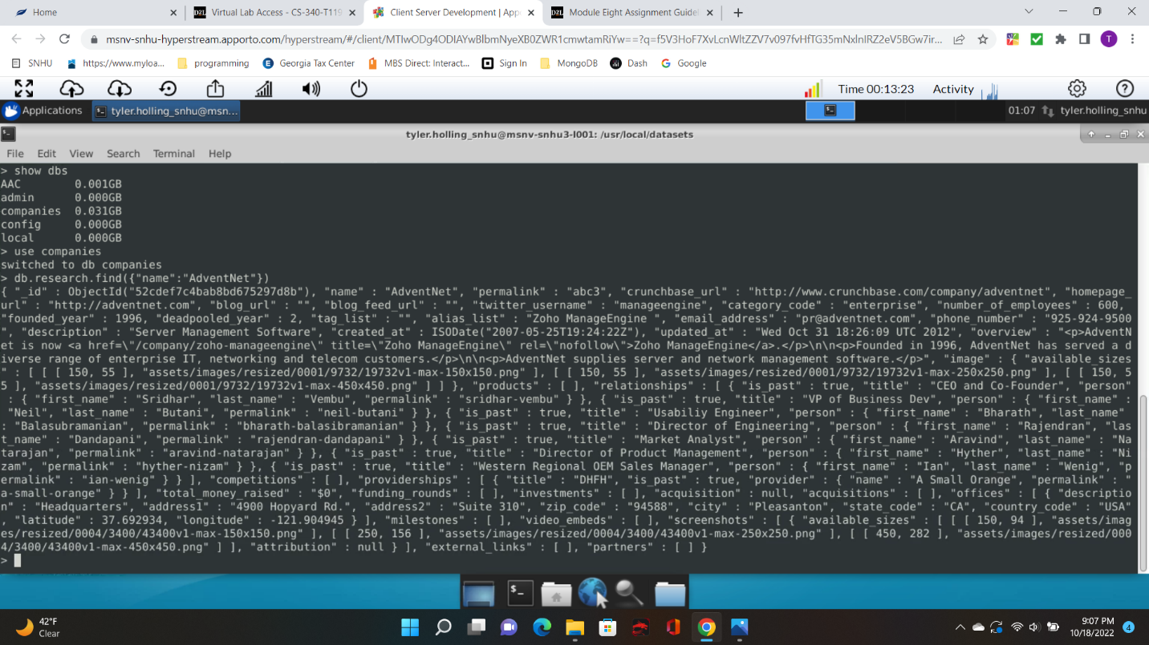

2)

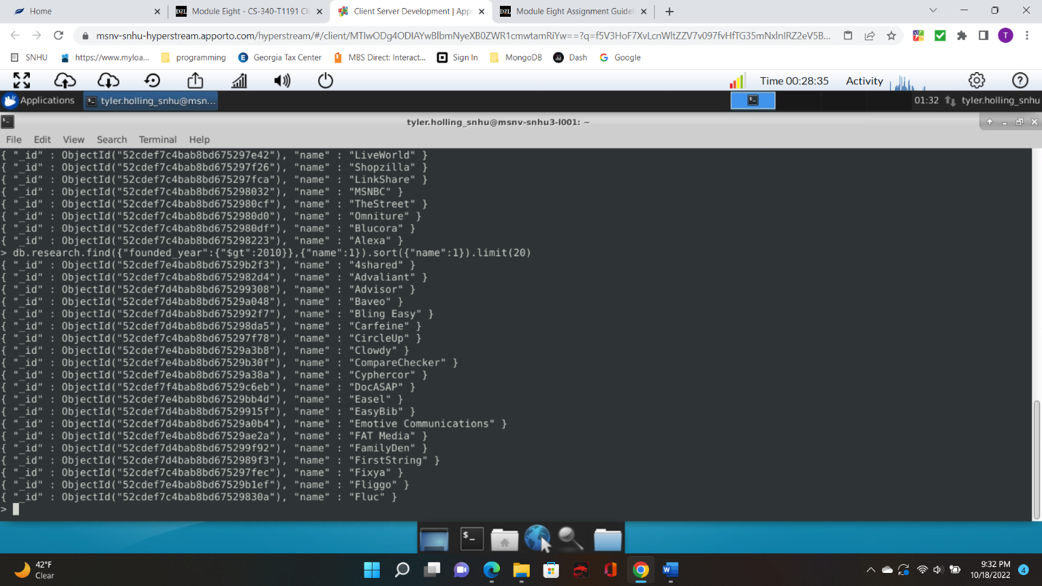

3)

